Wiegand ITC Instruction

Interface instruction of Wiegand module
The structure of Wiegand is like below, which should be fixed at the top of the shield inside：
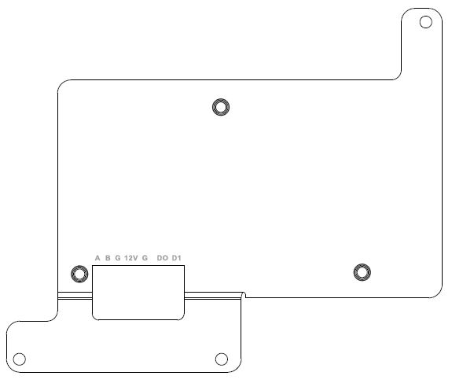
Figure 1

There are 2 4pin terminals connecting the camera and the Wiegand Module：
A, B —— RS485 of Wiegand module, connecting to the RS485 of camera
G, 12V —— The power of Wiegand module, connecting to the 12V output of the POE module inside the shield, as figure 2
G, D0, D1 —— The Wiegand 26bit data output of the device, connecting to the Wiegand input G, D0, D1 of the Access control mainframe
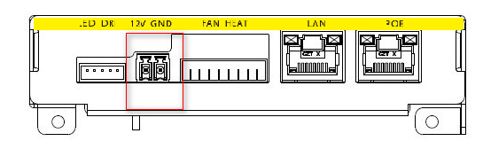
图2

Notice:
1, The Wiegand output only support Wiegand 26bit. Wiegand 34bit cannot support.
2, The transform and Wiegand output is defaulted and automatic supported. The plate number would be transformed to SHA-1 code.
3, The device only support POE+ power.

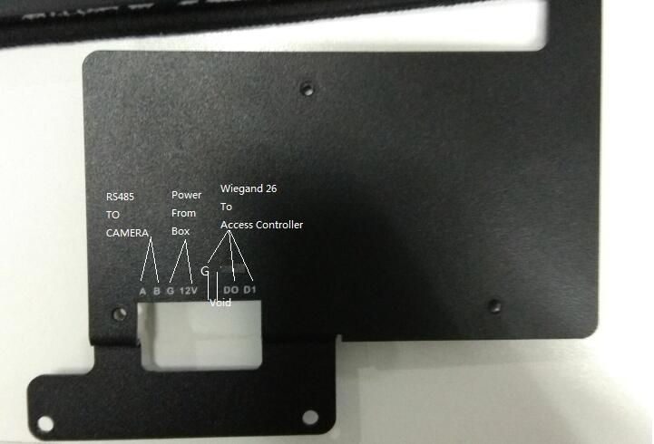

SHA-1 code:
Use Paxton.Net2.ANPR.Algorithm.exe like below:
Input the original plate number and get the Wiegand 26bits result.
For example: input plate number ABC123, the Wiegand 26bit value is 7573608.
